Motor speed control systems

MOTOR SPEED CONTROL SYSTEMS: A MICRO PROJECT REPORT
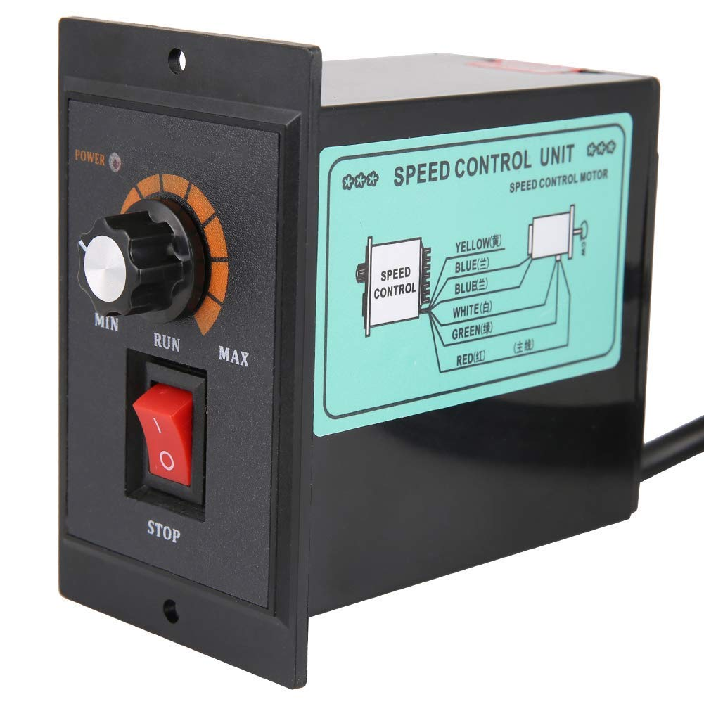

1. INTRODUCTION

Motor speed control is a fundamental aspect of modern industrial automation and electrical engineering. The ability to precisely regulate the rotational speed of electric motors is crucial for optimizing process efficiency, conserving energy, and ensuring the quality and safety of mechanical operations. This micro project report explores the principles, methodologies, and applications of various motor speed control systems.

1.1 Background and Significance

Electric motors convert electrical energy into mechanical energy and are the primary workhorses in nearly every industry. In many applications, a constant speed is insufficient; the motor must operate across a wide range of speeds to meet varying load demands (e.g., in pumps, conveyors, robotics, and electric vehicles). Speed control systems provide the necessary flexibility by manipulating the input parameters (voltage, current, or frequency) supplied to the motor.
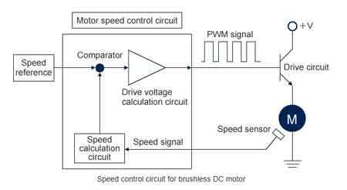

1.2 Scope of the Project

This report focuses on both Direct Current (DC) and Alternating Current (AC) motor control techniques, emphasizing modern methods utilizing power electronics, such as Pulse Width Modulation (PWM) for DC motors and Variable Frequency Drives (VFDs) for AC induction motors. The primary objective is to understand the transition from traditional mechanical control methods to highly efficient electronic control systems.

2. HISTORY OF MOTOR SPEED CONTROL
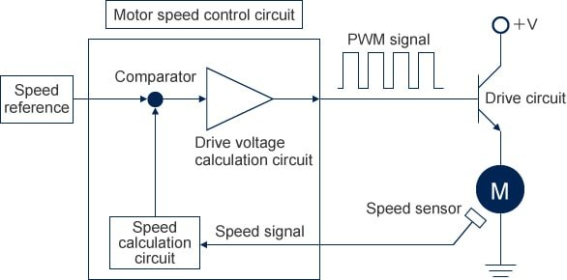
The evolution of motor speed control mirrors the development of electrical engineering itself, moving from crude mechanical methods to sophisticated digital systems.

2.1 Early Methods (Pre-1900s)

Initial attempts at controlling DC motor speed relied heavily on mechanical adjustments and resistive elements. Rheostats (variable resistors) were placed in series with the armature or field winding. While simple, these methods were highly inefficient, as the excess energy was dissipated as heat, leading to significant power loss.
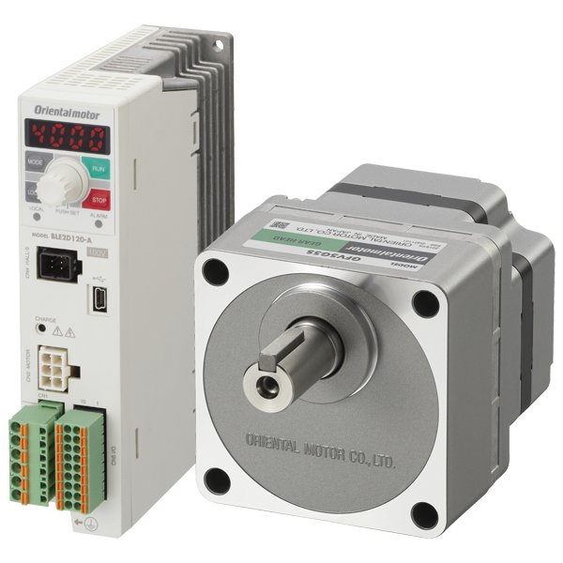

2.2 The Ward Leonard System (1890s)

The Ward Leonard system marked a significant breakthrough, offering smooth, precise speed control over a wide range. It involved using a motor-generator set to supply variable voltage to the main motor armature. Although highly effective and used widely in steel mills and elevators, it was bulky, expensive, and required extensive maintenance.

2.3 The Power Electronics Revolution (1950s – Present)

The invention of the Thyristor (SCR) in the 1950s revolutionized speed control. These semiconductor devices allowed for efficient switching and manipulation of high power levels. This led to the development of chopper circuits for DC motors and early inverters for AC motors. Modern control is dominated by Insulated Gate Bipolar Transistors (IGBTs) and microcontrollers, enabling high-frequency switching and complex algorithms like Vector Control (Field-Oriented Control).
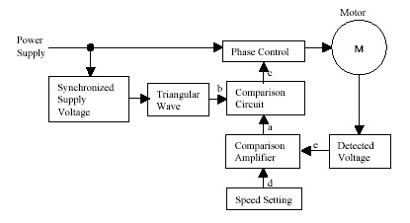

3. WORKING PRINCIPLE

The fundamental principle of motor speed control is based on the motor's speed-torque characteristics, which are governed by the basic equations of the motor type.

3.1 DC Motor Control Principle
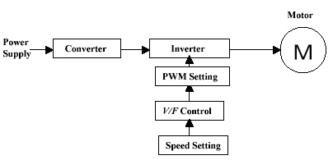
For a DC motor, the speed ($\omega$) is directly proportional to the back EMF ($E_b$) and inversely proportional to the field flux ($\Phi$):
$$\omega \propto \frac{E_b}{\Phi}$$
Since $E_b = V_a - I_a R_a$ (where $V_a$ is armature voltage), speed can be controlled by:
1. Varying the armature voltage ($V_a$).
2. Varying the field flux ($\Phi$).
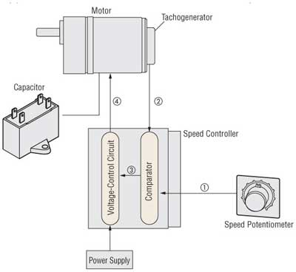

3.2 AC Motor Control Principle

For an AC induction motor, the synchronous speed ($N_s$) is determined by the frequency ($f$) and the number of poles ($P$):
$$N_s = \frac{120 f}{P}$$
The actual motor speed ($N$) is slightly less than $N_s$. Therefore, speed control is primarily achieved by varying the supply frequency ($f$). To maintain constant torque and prevent saturation, the ratio of voltage to frequency (V/f) must also be kept constant.

4. METHODOLOGY

The implementation of a modern motor speed control system involves a structured methodology encompassing hardware selection, control strategy development, and feedback integration.

4.1 Hardware Selection

The core hardware typically includes:
- Power Stage: A power electronic converter (e.g., H-bridge for DC, 3-phase inverter for AC) utilizing MOSFETs or IGBTs.
- Controller: A microcontroller (e.g., Arduino, PIC, DSP) or a dedicated industrial controller (PLC, VFD).
- Sensing Elements: Tachometers or encoders for speed feedback, and current sensors for protection and torque estimation.

4.2 Control Strategy (PWM Implementation)

For precise control, Pulse Width Modulation (PWM) is the standard technique. The methodology involves:
1. Input: Defining the desired speed (setpoint).
2. Error Calculation: Comparing the setpoint with the actual measured speed (feedback).
3. Controller Action: A Proportional-Integral-Derivative (PID) controller processes the error and generates a duty cycle command.
4. Modulation: The microcontroller generates a high-frequency PWM signal corresponding to the calculated duty cycle.
5. Actuation: The PWM signal drives the power stage, effectively varying the average voltage supplied to the motor, thus adjusting the speed.

5. CLASSIFICATION OF CONTROL SYSTEMS

Motor speed control systems can be broadly classified based on their operational structure and the complexity of the control loop.

5.1 Open-Loop Control

In open-loop systems, the control signal is applied directly to the motor without measuring the output speed. The control action is based solely on the input command.
- Advantages: Simple, low cost.
- Disadvantages: Poor accuracy, highly sensitive to load variations and voltage fluctuations.

5.2 Closed-Loop Control (Feedback Control)

Closed-loop systems utilize sensors (encoders, tachometers) to measure the actual motor speed and compare it to the desired speed (setpoint). The controller continuously adjusts the input power until the error is minimized.
- Advantages: High accuracy, fast response, robust against disturbances.
- Disadvantages: Increased complexity and cost due to sensors and sophisticated controllers.

6. TYPES OF MOTOR SPEED CONTROL

Specific techniques are employed depending on the type of motor being controlled.

6.1 DC Motor Control Types

- Armature Voltage Control: Used for speeds below the base speed. Speed is varied by changing the voltage applied across the armature while keeping the field flux constant. This provides constant torque operation.
- Field Flux Control: Used for speeds above the base speed (field weakening). Speed is increased by decreasing the field current, which reduces the magnetic flux. This provides constant power operation.

6.2 AC Motor Control Types

- Scalar Control (V/f Control): The simplest method for AC motors. It maintains a constant V/f ratio to ensure the magnetic flux remains constant, thus providing constant torque up to the base speed.
- Vector Control (Field-Oriented Control - FOC): A highly advanced technique that allows the control of the motor's flux and torque components independently, similar to controlling a DC motor. This provides extremely precise speed and torque response, essential for high-performance applications like robotics and traction.

7. APPLICATIONS

Motor speed control systems are indispensable across numerous industrial and commercial sectors.

7.1 Industrial Automation

Used extensively in conveyor belts, packaging machinery, and assembly lines where precise synchronization and variable throughput rates are required.

7.2 Heating, Ventilation, and Air Conditioning (HVAC)

Variable speed drives (VSDs) are used in pumps and fans to adjust flow rates based on demand, leading to massive energy savings compared to fixed-speed systems.

7.3 Transportation

Electric vehicles (EVs) and hybrid vehicles rely entirely on sophisticated vector control systems to manage traction motor speed and regenerative braking.

7.4 Robotics and CNC Machines

High-precision control systems (often FOC) are necessary for the accurate positioning and movement required in robotic arms and computer numerical control (CNC) equipment.

8. RESULTS (EXPECTED OUTCOMES)

A successful implementation of a motor speed control system, particularly a closed-loop PWM system, yields measurable performance improvements.

8.1 Speed Regulation

The system should demonstrate excellent speed regulation, maintaining the setpoint speed within a tolerance of $\pm 1\%$ despite sudden changes in mechanical load.

8.2 Transient Response

The time taken for the motor speed to settle to the new setpoint after a command change (rise time and settling time) should be minimal, ideally less than 500 milliseconds, indicating a fast and responsive control loop.

8.3 Energy Efficiency

By operating the motor only at the required speed and torque, the system significantly reduces power consumption compared to using mechanical throttling or resistive control methods.

9. ADVANTAGES OF ELECTRONIC SPEED CONTROL

Modern electronic control systems offer significant benefits over traditional methods.

- High Efficiency: Power electronics minimize energy loss, leading to substantial operational cost savings.
- Precision and Accuracy: Closed-loop systems provide highly accurate speed and position control, crucial for complex manufacturing processes.
- Soft Starting: Electronic control allows for smooth acceleration and deceleration, reducing mechanical stress on the motor and connected machinery.
- Wide Speed Range: Controllers can operate motors effectively from near zero speed up to maximum rated speed.

10. DISADVANTAGES

Despite the numerous advantages, electronic speed control systems do present certain challenges.

- Complexity and Cost: High-performance controllers (like VFDs) are complex and require specialized knowledge for installation, programming, and maintenance.
- Harmonics: The high-frequency switching of power electronic devices can introduce harmonic distortion into the power supply, potentially affecting other sensitive equipment.
- Acoustic Noise: PWM switching can sometimes generate high-frequency acoustic noise in the motor windings.
- Motor Insulation Stress: The rapid voltage changes (high $dv/dt$) generated by VFDs can stress the insulation of standard motors, sometimes requiring inverter-duty rated motors.

11. CONCLUSION

Motor speed control systems are the backbone of modern industrial efficiency and precision. This micro project demonstrated that the transition from inefficient resistive control to sophisticated power electronic techniques (PWM, VFD, FOC) has enabled unparalleled control over motor dynamics. Closed-loop systems, utilizing microcontrollers and advanced algorithms, ensure high accuracy, fast response, and significant energy savings, making them essential components in nearly every sector of engineering and technology. Continued development focuses on improving sensorless control and integrating AI for predictive maintenance.

12. REFERENCES

1. Bimbhra, P. S. (2012). Power Electronics. Khanna Publishers.
2. Rashid, M. H. (2014). Power Electronics: Circuits, Devices, and Applications. Pearson Education.
3. Theraja, B. L., & Theraja, A. K. (2005). A Textbook of Electrical Technology (Volume II: AC and DC Machines). S. Chand Publishing.
4. Mohan, N., Undeland, T. M., & Robbins, W. P. (2003). Power Electronics: Converters, Applications, and Design. John Wiley & Sons.

